图片供参考
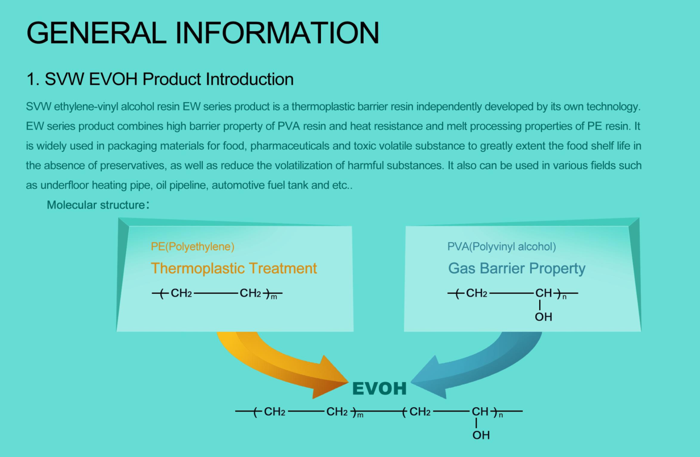
EVOH Product Introduction
EW series product combines high barrier property of PVA Resin and heat resistance and melt processing properties of PE Resin.It is widely used in packaging materials for food, pharmaceuticals and toxic volatile substance to greatly extent the food shelf life in the absence of preservatives, as well as reduce the volatilization of harmful substances. It also can be used in various fields such as underfloor heating pipe, oil pipeline, automotive fuel tank and ect
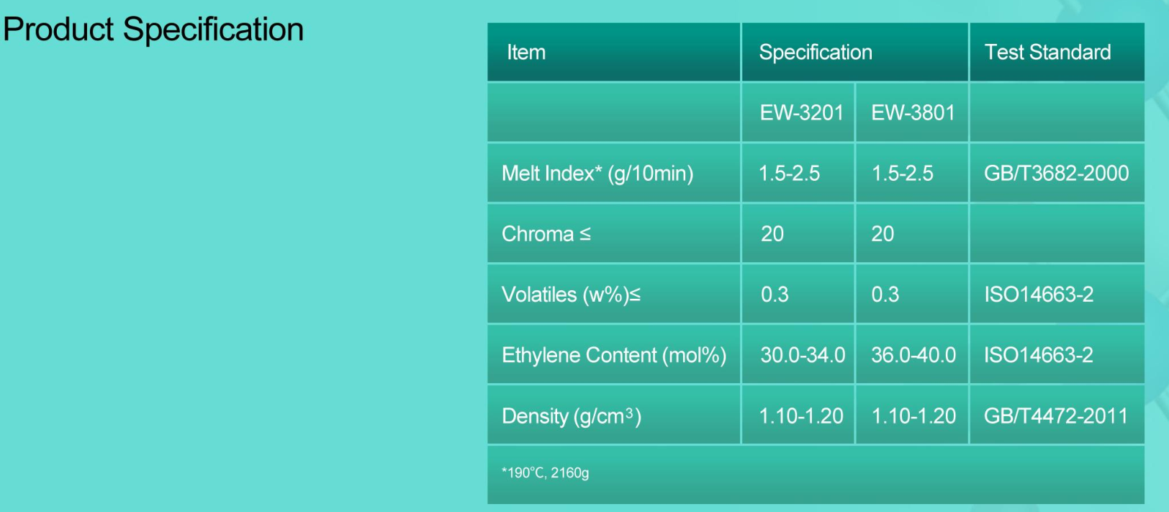
Product Specification
Item | Specification |  | Test Standard
 | EW-3201 | EW-3801
Melt Index(g/10min) | 1.5-2.5 | 1.5-2.5 | GB/T3682-2000
Chroma≤ | 20 | 20
Volatiles(w%)≤ | 0.3 | 0.3 | ISO14663-2
Ethylene Content(mol%) | 30-34 | 36-40 | ISO14663-2
Density(g/cm3) | 1.10-1.20 | 1.10-1.20 | GB/T4472-2011
190℃,2160g

